Compassion Food Drive
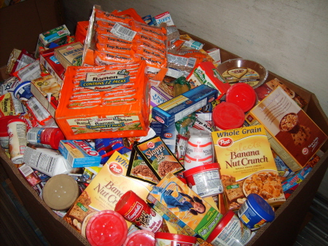
(Taken from LAD Leader Guide for June 2009)

Explain that one way we show compassion is to meet
basic human needs, like food and shelter.
Tell the boys and girls that they will be collecting food for a local food bank. Bring several large boxes if they would like to draw pictures of different food items.
Tape a list of food items the food bank is looking for on the side of the boxes. Distribute the boxes around the church. Put a note in the church bulletin/newsletter promoting the project.

